# CP2403 Project Part 1

# Data Exploration, Management & Visualization

**First Name: Shwe Moe**

**Last Name: Thant**

1. Box plot

|  |
| --- |
| Question: How does the Silicate concentration of the water change as water depth increases up to a depth of 1000m?  categorical variable: Depth (m)  quantitative variable: Silicate Concentration (µmol/L) |

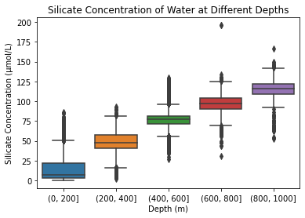

What is conclusion can you draw from the box plot?

|  |
| --- |
| In conclusion, the box plot visualization of silicate concentration across different depth categories provides valuable insights into the distribution of silicate levels in water. The analysis indicates a discernible trend of increasing silicate concentration with water depth. This upward trend appears to be consistent up to a depth of 1000 meters, suggesting a linear relationship between depth and silicate concentration with this range. |

1. Histogram

|  |
| --- |
| Question: What is the frequency distribution of temperature recordings for water depth of up to 50m?  quantitative variable: Temperature in Degrees Celsius |

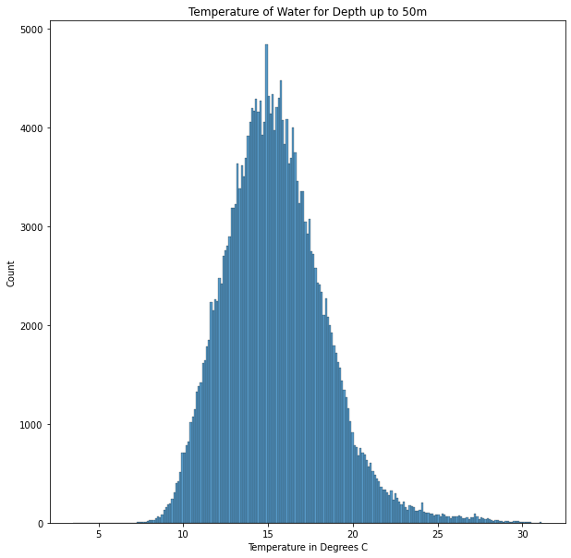

What is conclusion can you draw from the histogram?

|  |
| --- |
| In summary, the histogram visualization depicting water temperature distribution for depths up to 50 meters reveals a distinctive pattern. The distribution is unimodal, indicating a single prominent peak, and slightly skewed to the right. This skewness suggests that the tail of the distribution extends towards higher temperatures. The most frequent temperature value, represented by the highest peak in the histogram, is cantered around 15 degrees Celsius. |

1. Line chart

|  |
| --- |
| Question: what is the relationship between water depth and oxygen concentration for water depth of up to 500m?  quantitative variable: Oxygen Concentration (µmol/Kg) |

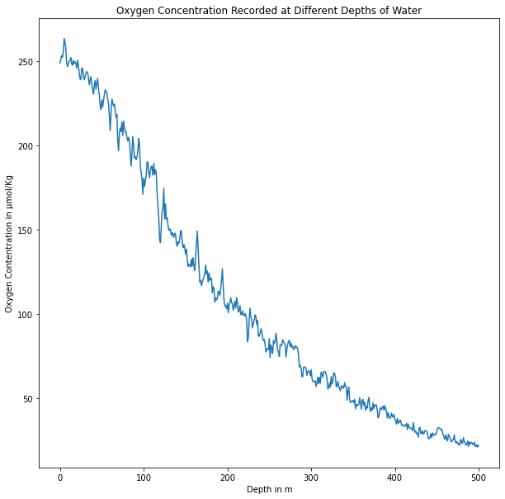

What is conclusion can you draw from the line chart?

|  |
| --- |
| The line chart illustrating the relationship between water depth and oxygen concentration provides a clear insight into the oxygen dynamics within the studied aquatic environment. The trend depicted in the chart suggests a consistent pattern: as water depth increases, the oxygen concentration of the water tends to decrease. This inverse relationship is evident across depths up to 500 meters. Such observations align with our understanding of how oxygen levels may change as we move deeper within the water column. |

1. Bubble.

|  |
| --- |
| Question: What is the correlation between Nitrite, Nitrate, and Ammonium Concentration for water depths of up to 50m?  quantitative variable 1: Nitrite Concentration (µmol/Kg)  quantitative variable 2: Nitrate Concentration (µmol/Kg)  quantitative variable 3: Ammonium Concentration (µmol/Kg) |

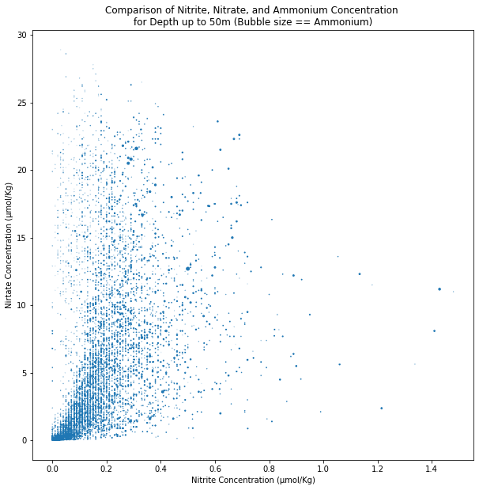

What is conclusion can you draw from the bubble chart?

|  |
| --- |
| The bubble chart showcasing the interplay of nitrite, nitrate, and ammonium concentrations provides a comprehensive visual representation of their relationships within the aquatic environment, specifically at depths up to 50 meters. The chart indicates a discernible positive correlation between nitrite and nitrate concentrations, suggesting that as one of these compounds increases, the other tends to follow suit. |

1. Selected Chart.

|  |
| --- |
| Selected Chart: HeatMap  Question: How many phosphate concentration readings were above the mean phosphate value for water depths of up to 250m?  Variables used:  Variable 1: Depth (m)  Variable 2: Phosphate Concentration (µmol/Kg)  Variable 3: Counts |

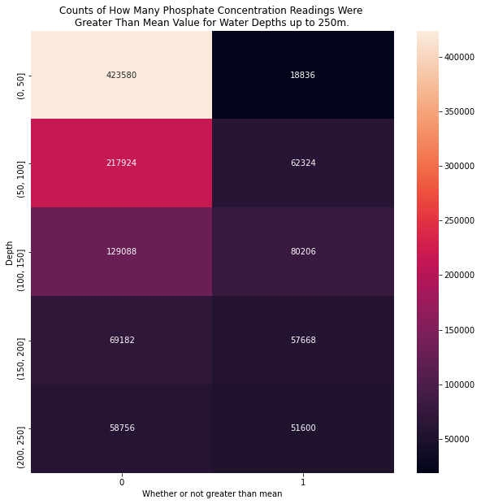

What is conclusion can you draw from your selected chart?

|  |
| --- |
| The heatmap visualization offers insights into phosphate concentration distributions across different water depths (up to 250m) concerning their relation to the mean value. Shallow waters (0-50m) exhibit more measurements, with the majority of phosphate levels below the mean. As depth increases, the ratio of values above the mean to those below the mean diminishes, indicating a decreasing trend in values above the mean with greater depth. This suggests potential shifts in nutrient dynamics across varying depth ranges. |